Nama : Ftrah Andhika Ramadhan

Kelas : SI4503

NIM : 1202213051

Problem 1: Validate a Bank PIN

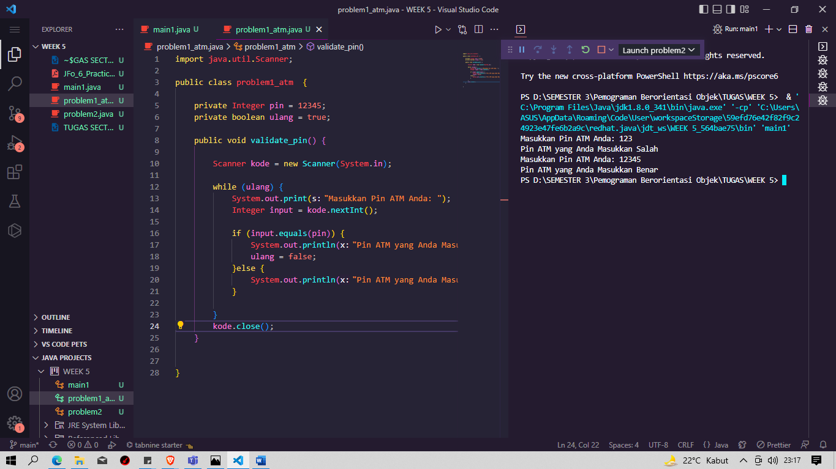

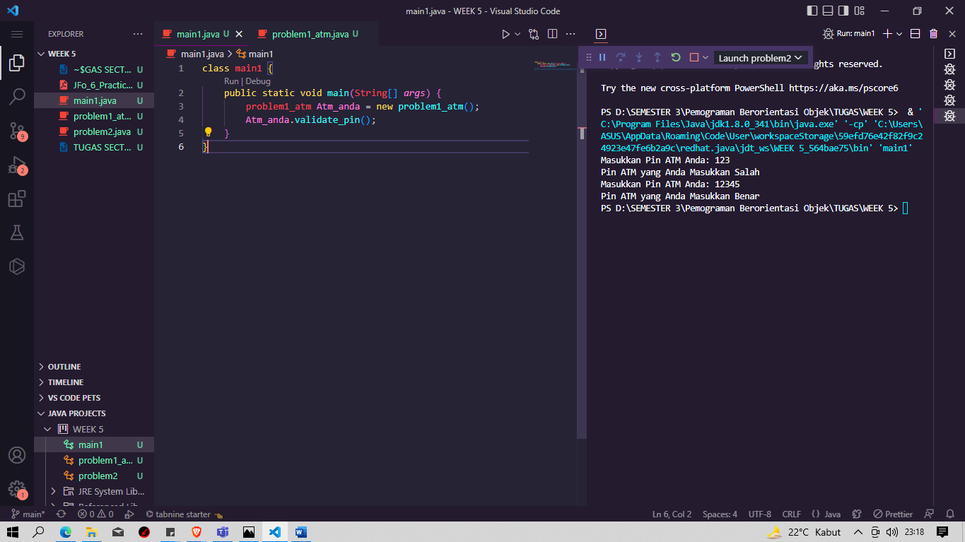

Problem 2: Displaying Multiples of a Number

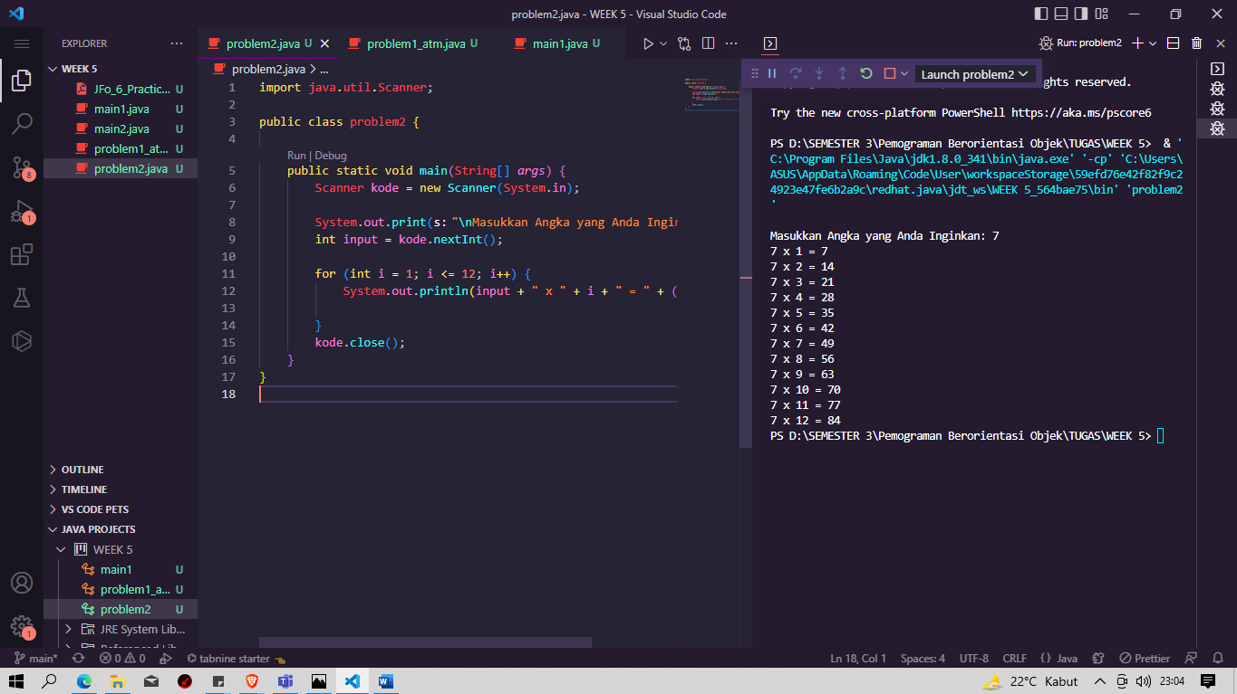

Problem 3: Programmatic ASCII Art

